October 2, 2022 - Fr JC’s Pastoral Letters to Little Flower -  Church of the Little Flower, Berkeley Heights, NJ  Pastoral Letter to Little Flower (XI) - “Respect Life Month” | 20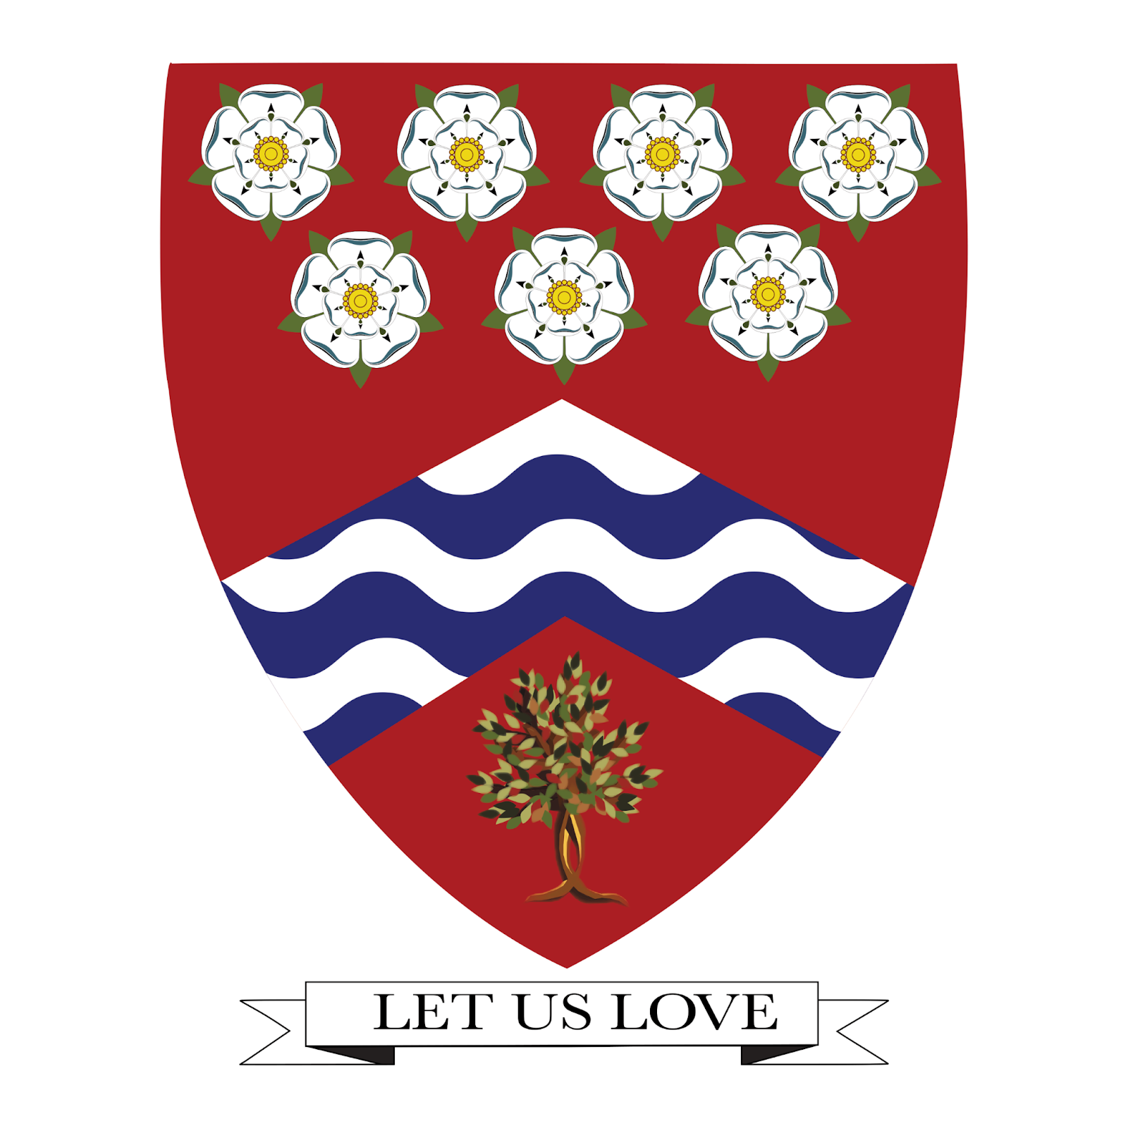22

Dear Little Flower,

October 1 is the Feast Day of Our Patroness: St Therese of Lisieux. For those who have prayed the 9-Day Novena of St Therese, thank you for journeying with us in prayer. Happy Feast Day everyone!
I have got to say: there were some “down hill” and sad moments but, the last couple of weeks have generally been very enjoyable for me. The last Cornhole Tournament hosted by Fr Matt was great - it was just nice to come together and make community and meet one another in the context of healthy “competition”! Kudos to the “Bromeos” for winning this year’s tournament! Another success was our Golf-Outing at Foxhole, Barnchburg, NJ - thank you for the Golf-Outing Team for giving us their time and expertise to put up such a huge, and fun-filled, event. I am looking forward to a lot more community events in the future.
From me to our 2022 Confirmation teens: Congratulations! Thank you for saying “yes” to the Lord’s invitation to receive His Spirit - and for taking this step to be closer to Him and deepen your friendship with Him. You guys have received the gift of the Holy Spirit (from your Baptism, and now strengthened by your commitment today) - alongside this gift is the beginning of your young-adult journey to recognize your particular charisms and callings (vocation) from the Lord. I remember my own journey when I was your age, and received my confirmation: many things happened, but the only things that mattered and that were joy-filled were events that led me to true friendships and my deeper relationship with Jesus. So, my intention is to be with you on this journey of prayerful discovery and spirit-led adventure! We are planning lots of fun-filled, faith-filled and Encounter-Jesus events for you. Looking forward to spending time with you, our dear teens, to build community and friendships, as you make your way deeper into our faith as Confirmands and disciples of Christ!
As a parish, I am happy to know that families at Little Flower love being together! There is good spirit that overflows from our parish to our little town everytime we - as a community - celebrate the gift of faith and one another!
My dear pilgrims, this month of October, we will be celebrating Respect Life Month - our little way of celebrating the gift of human life that comes from God, namely: The gift of Community & Family Life (Week 1); The gift of Health & Healing (Week 2); The gift of Wisdom & Old Age (Week 3); The gift of Mothers and Babies (Week 4); The gift of the Journey in Transition into New Life - End of Life (Week 5). May God bless our month’s journey as a parish!

Your Parish Priest,
Fr. JC Merino

